L8-W8-DBS301-Set Operators

This is the week after the break

Do not submit the quiz. Answers available in the Oracle notes
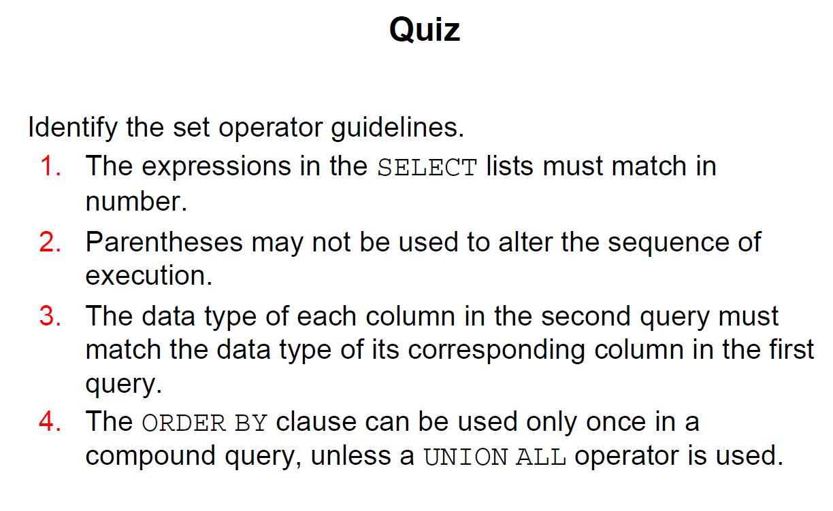

THE ANSWER TO THE ABOVE IS ➔ 1, 3

1 The HR department needs a list of Department IDs for departments that do not conbtain the job ID of ST_CLERK> Use a set operator to create this report.
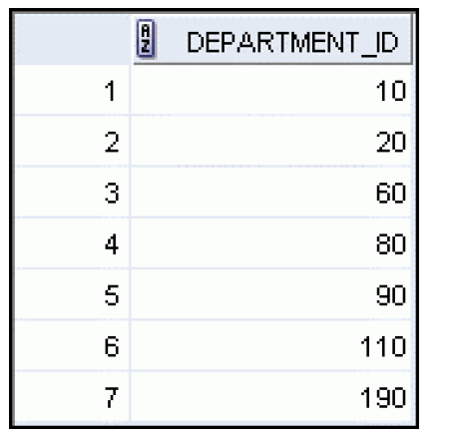

select department_id
from departments
MINUS
select department_id
from employees
where job_id = 'ST_CLERK';
--that do not contain job of ST_CLERK

DEPARTMENT_ID
-------------
10
20
60
80
90
110
190

7 rows selected

2 Same department requests a list of countries that have no departments located in them. Display country ID and the country name. Use SET operators.
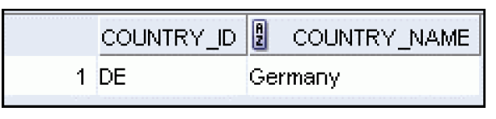
select country_id, country_name
from countries
minus
select country_id, country_name
from countries
join locations using(country_id)
join departments using(location_id);
CO COUNTRY_NAME
-- ----------------------------------------
AR Argentina
AU Australia
BE Belgium
BR Brazil
CH Switzerland
CN China
DE Germany
DK Denmark
EG Egypt
FR France
HK HongKong

CO COUNTRY_NAME
-- ----------------------------------------
IL Israel
IN India
IT Italy
JP Japan
KW Kuwait
MX Mexico
NG Nigeria
NL Netherlands
SG Singapore
ZM Zambia
ZW Zimbabwe

22 rows selected

3 The Vice President needs very quickly a list of departments 10, 50, 20 in that order. job and department ID are to be displayed
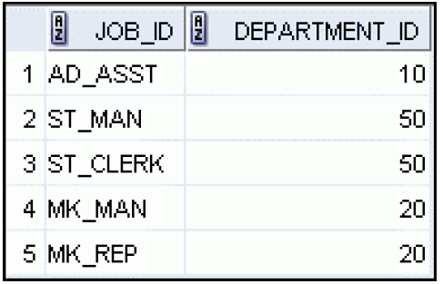

select distinct job_id, department_id
from employees
where department_id = 10
union all
select distinct job_id, department_id
from employees
where department_id = 50
union all
select distinct job_id, department_id
from employees
where department_id = 20;

JOB_ID DEPARTMENT_ID
---------- -------------
AD_ASST 10
ST_MAN 50
ST_CLERK 50
MK_MAN 20
MK_REP 20

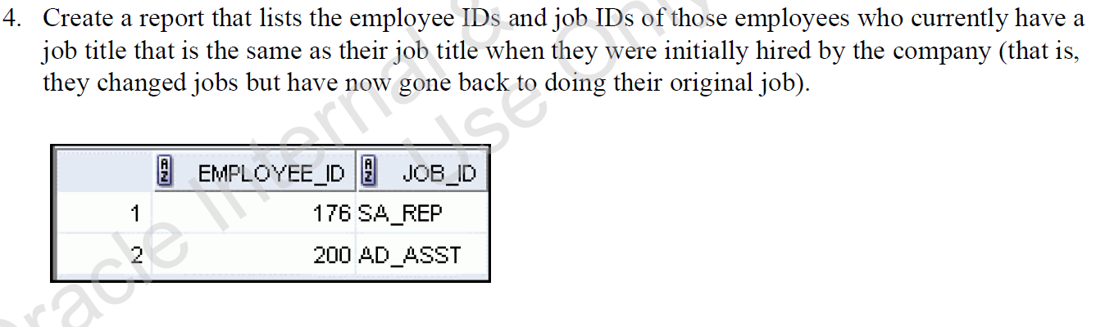
select employee_id, job_id
from employees
intersect
select employee_id, job_id
from job_history;

EMPLOYEE_ID JOB_ID
----------- ----------
176 SA_REP
200 AD_ASST

EXTRA QUESTION

Try doing it without looking at the answer

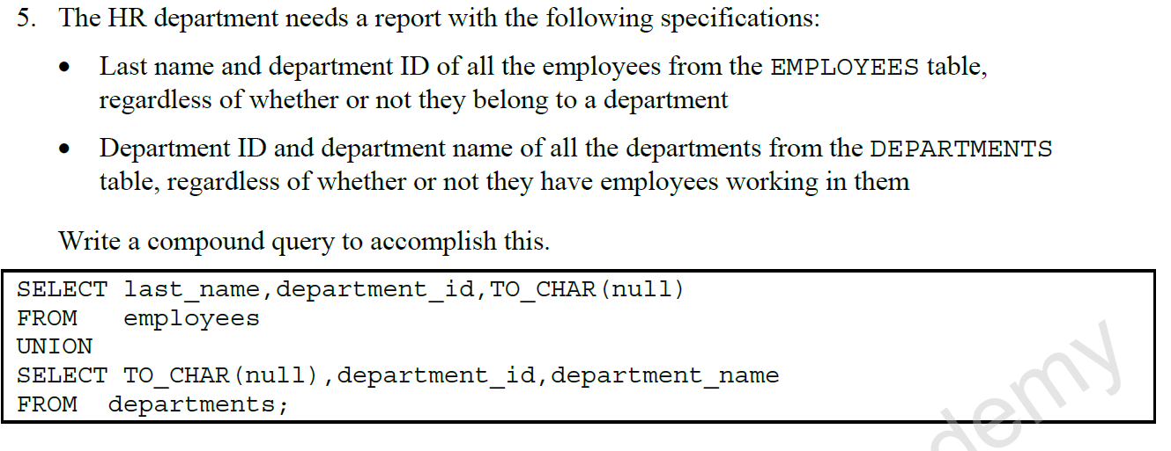

select last_name, department_id, to_char(null)
from employees
union
select to_char(null), department_id, department_name
from departments;

LAST_NAME DEPARTMENT_ID TO_CHAR(NULL)
------------------------- ------------- ------------------------------
Abel 80
Davies 50
De Haan 90
Ernst 60
Fay 20
Gietz 110
Grant
Hartstein 20
Higgins 110
Hunold 60
King 90

LAST_NAME DEPARTMENT_ID TO_CHAR(NULL)
------------------------- ------------- ------------------------------
Kochhar 90
Lorentz 60
Matos 50
Mitrakhovich 90
Mourgos 50
Rajs 50
Taylor 80
Vargas 50
Whalen 10
Zlotkey 80
10 Administration

LAST_NAME DEPARTMENT_ID TO_CHAR(NULL)
------------------------- ------------- ------------------------------
20 Marketing
50 Shipping
60 IT
80 Sales
90 Executive
110 Accounting
190 Contracting

29 rows selected

